Emerson College

Banner 9 (Administration Pages) – Navigation Guide

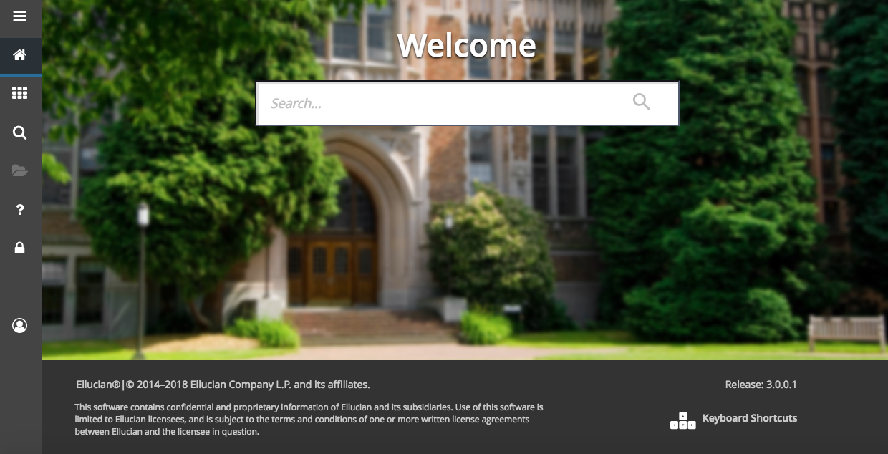

Table of Contents

Page | Content
3 | Introduction
3 | Structure and Usability Improvements
4 | Basic Navigation
5 | Page Header
5 | Sign out of Banner when Done
5 | Key Block
6 | Sections
6 | Bottom Navigation Section of a Page
6 | Notification Center
7 | Data Display Options
7 | Filtering Data
9 | Wild Card Lookup
10 | Multiple Records
10 | One Record at a Time
11 | In the Grid
11 | Advanced Features
12 | My Banner Personal Menu
14 | Banner 9 Browser Recommendations
15 | Banner 9 Accessibility
16 | Banner Keyboard Shortcuts
18 | Banner Frequently Asked Questions

Introduction
Banner 9 (called Admin Pages) is a complete design and upgrade for the Banner ERP system. The redesign of the Ellucian system is to improve the user’s experience with new tools and improved capabilities so that the new efficiencies will allow administrative departments to focus on student success.

Banner 9 provides updated functionality for: faculty grading, student advising, financial services, student services and registration. Banner 9 is phasing out Banner 8 (and previous versions) technology including Oracle forms and eliminating running Java (JRE) in the browser.

Banner 9 continues providing single sign-on functionality, while providing an additional product called the Application Navigator (App Nav) that will make new modules and the admin pages more accessible and user-friendly. The new advantages include:

- Eliminating web browser compatibility issues - ending dependency on Internet Explorer, now supporting: Chrome, Firefox, Safari, and MS Edge
- Easier navigation between forms (now known as pages)
- A ‘Google Like’ search option

Structure and Usability Improvements
Application Navigator is a “Google like” experience for navigating throughout Banner Admin pages, offering multiple ways to search.

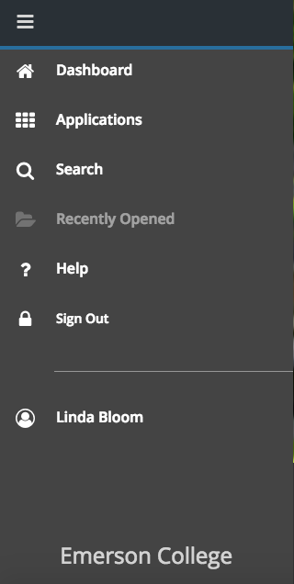
User Name

Search

The reorganization of the Banner Administrative menu includes the key area of Banner 9:

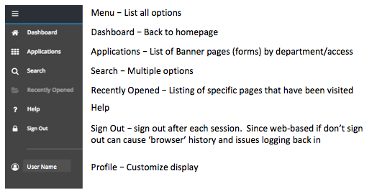

The key areas to the Application Navigator:
- Menu icon (CTRL+M) – The Menu icon opens to the above options. Under Applications will list the Banner pages and My Banner menu to the departments and pages that are assigned to the user by permissions.
- Search icon (CTRL+Shift+Y) – The Search icon is used similar to a Google search by typing in a descriptive name, ID or a Banner acronym.
- Recently Opened icon (CTRL+Y) – The Recently Opened icon displays the latest pages that have been opened by the user.
- Search box in the center of the page (CTRL+Home) – Enter a descriptive name, ID or a Banner acronym for the page.

Basic Navigation
The basic navigation of each page (previously Forms) includes: page header, key block, sections, notification center, and buttons.

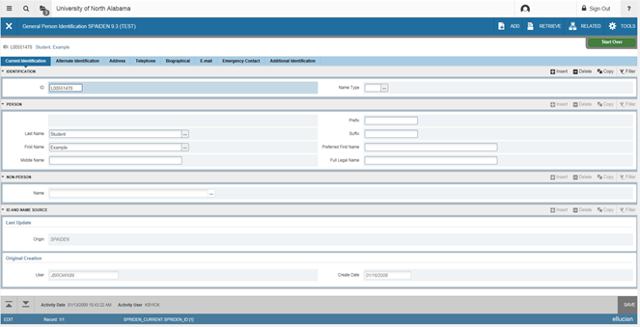

Page Header

The page header is part of the basic navigation and contains the following items:

- Page close icon “X” – Always use the close icon to close a page.
- Page title – Includes description, acronym, version, and database.
- Add and Retrieve icons – Used with Banner Document Management (Xtender).
- Release and Submit buttons – Displayed only with a workflow.
- Related Menu button – Displays a list of pages that can be accessed from this page.
- Tools Menu – includes refresh, export, print, clear record, clear data, item properties, display ID image, and other options controlled by the page.
- Notification Center – Located at the right of the Tools Menu and displays communications and information to the user: successful save of data, warning messages, error messages, informational messages, number of messages to be corrected to continue in the page. Click in the box with the number in the page header to open or close the Notification Center.

Sign Out of Banner when Done
It is important to remember to use the Sign Out link in the upper right corner when closing the application. If Banner 9 is closed with out signing out, the browser history is not cleared and may not show real-time data when logging back in.

Key Block

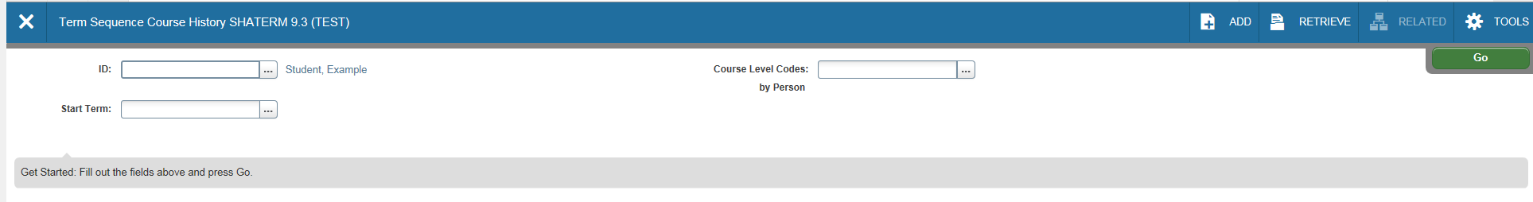

The first block on most pages contains key information. The key block determines what data is entered or displayed on the rest of the page. All the information on the page is related to the key block. The key block stays on the page as subsequent sections are displayed.
- When the cursor is in the key block, the fields that can be entered in the key block are enabled. When leaving the key block, the fields in the key block are disabled.
- When the cursor is in the key block, the information is displayed in a column format. When leaving the key block by clicking the Go (previously Next Block) button, the data is rearranged into a linear format and cannot be reentered.
- To access the body of the page, populate the key block data and then click Go.
- To return to the key block if in the body of a page - click Start Over (previously Rollback).

Sections

Pages are divided into sections (previously blocks) that contain additional details for the key information. A section can represent one record or multiple records depending on the type of information on the page. Each section contains related information.

Sections of data are accessed by scrolling up and down the page, and can be opened or collapsed by clicking on the arrow on the far left side of the section header. Some sections can be accessed by using tabs that group information together, If available, sections can have a header that includes icons for the following actions:
- Insert – Use to insert records in the section.
- Delete – Use to delete records in the section.
- Copy – Use to copy records in the section.
- More Information – Only appears if supplemental data can be entered for the record. The icon is displayed with a check mark if supplemental data already exists for the record.
- Filter – Use to filter records in the section.

Bottom Navigation Section of a Page

The bottom section of a page contains icons used for navigation, perform functions, and display additional information.
- Previous Section button (Up Arrow icon) – Move backwards in the sections (Alt+ Page Up).
- Next Section button (Down Arrow icon) – Go to the next section of the page (Alt+ Page Down).
- Activity Date – Current system time - time stamped for the record if created or modified.
- Activity User – Name of account user creating or modifying the record
- Save button – Use to save your data. Error Message Types

Notification Center
Banner communicates with the user and notifies them of issues and activities during the processing process in Banner pages. There are four key messages:

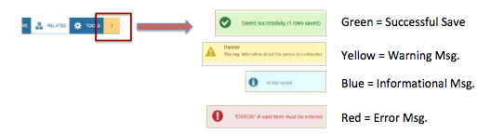

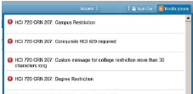
Error messages are displayed in red and affiliated with the field/record error. These are outlined by Banner page and outlined in the upper right hand corner of the Banner page.

Data Display Options
- Required Fields
  - An asterisk (*) displayed next to a field name indicates that the field requires a value before you continue on the page. The system uses the definition of the field as it is used in the application to determine if it is required.
  - Fields that have conditional logic that determines whether they are required, the asterisk (*) is not displayed. If a user leaves a section or a page without entering information in a required field, the page notifies the individual in the Notification Center, requiring the user to perform some additional action.
- Sort Order
  - In a grid layout, values for a field can be sorted and, if the user chooses to sort the data, an up or down arrow next to the field name indicates the current sort order for the field. Click the field label to reverse the sort order.
- Dates
  - Enter the date directly or use the calendar icon for date selection. The date format is mmddyyyy. To enter the current date, type any letter and [TAB].
- Lookup
  - The Lookup feature allows to quickly search a value for a field. The Lookup button next to a field indicates that the field has the Lookup feature.
  - Click the Lookup button (…), enter a filter value, and press Enter to display results that match the filter criteria. Select a value and click OK, or double-click a value to return the value to the calling page.

Filtering Data
Data can be filtered in a section if there is an active Filter icon in the section header. Use the following steps to filter data in a section.

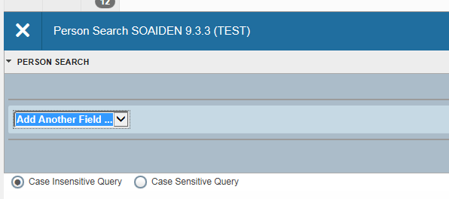
- Click the active Filter (F7) icon for the section.
- Choose the field you want to filter from the Add Another Field drop down list.
- Choose an operator from the Contains drop down list. The available operators depend on the type of field (numeric, alphanumeric, date, check box, or other).

The Contains operator is available for alphanumeric and other fields only. The Between operator includes the values entered. For example, for codes “between” 1 and 5, the values 1, 2, 3, 4, and 5 are considered. Required fields do not use the Is Null and Is Not Null operators.

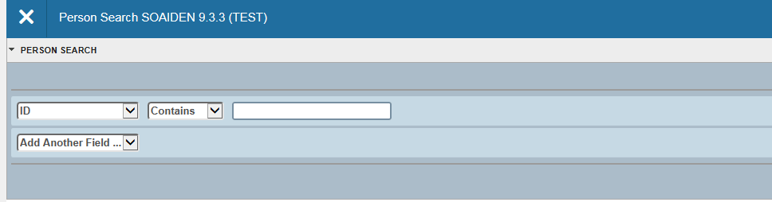

Enter a value for the field you selected.

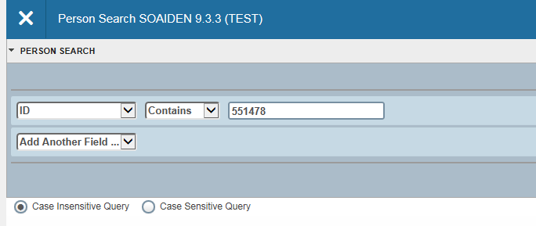

Optional:
- To add another field to the filter criteria, choose a field from the Add Another Field dropdown, select an operator, and enter a value for the field that you selected. Repeat this step until all filter criteria are entered.

When all filter criteria are entered, click Go (F8) to display the filter results. The number of records retrieved is displayed at the bottom of the section. The results for a field can be sorted in ascending or descending order by clicking on the field label in the column header. You can reverse the sort order by clicking the field label.

Optional:
- To perform another filter, click Filter Again.
- To close the filter and display all unfiltered records, click the lowercase x in the upper corner of the filter window to close the filter.
Wild Card Lookup
When utilizing the Lookup option perform either exact match lookups or partial match lookups when some of the information is unknown. To perform a partial match lookup, use a “%” to replace the unknown information. For example, when searching for a student with an incomplete ID number enter the known information as (beginning of student ID…..%##%).

Select the lookup icon (…).

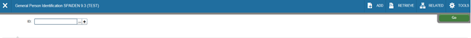

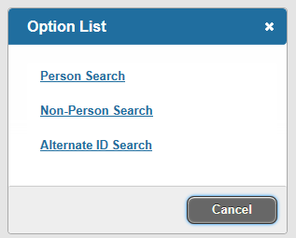
Choose the type of search to be completed from the option list.

Begin the filter process by selecting the appropriate filter. (i.e. ID, Last Name, etc.)

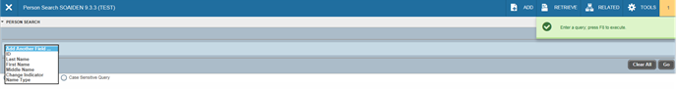

Choose the appropriate operator for the list.

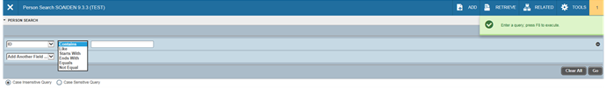

Add any additional filters if any additional information is known. Select Go button.
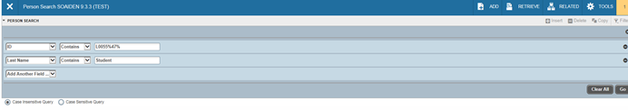

A list of compatible information will be outlined. Use the Select button from the lower right of the form or select Cancel.

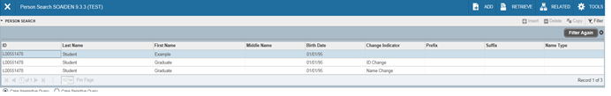

The selected information will be returned to the calling page.

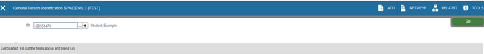

Multiple Records
Data can exist in multiple records of the same type in the database, for example addresses, and are displayed in multiple ways. Records can be viewed one record at a time or in a grid.

One Record at a Time
In this instance, the details of the data are not displayed in a table grid, but rather in a more easily readable manner. To move from record to record use the pagination controls (the arrows located in the bottom left hand corner)

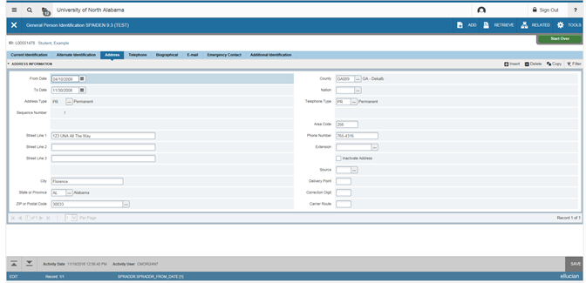

In the Grid
In this instance, the data is presented in column and row format. May need to scroll to view all the data. Page through the records using the pagination controls, decide how many records to review in the grid, and sort the data in ascending or descending order by clicking on the arrows next to the column heading.

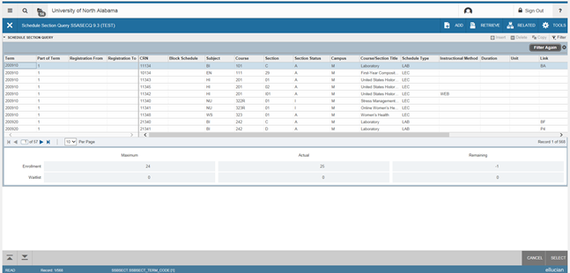

Advanced Features:

Item Properties

Item Properties lists all properties for the field where the cursor is currently located. Item properties include the field’s internal database name, whether the field is required, type of data (character or numeric), maximum length, and other characteristics of the field. The specific properties that are displayed depend on the type of field. To display Item Properties for a field, place the cursor in the field and select Tools > Item Properties.
My Banner Personal Menu
You can create a personal menu tied to your Banner user ID. Your personal menu will contain the pages, jobs, menus, and Quickflows that are most important in your daily work. Once the personal menu is created, you may access it from the main menu.

From the Application Navigator page, click on the Search area and type in “GUAPMNU” or “My Banner”

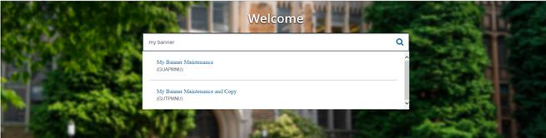

The My Banner maintenance page contains:
- Type: A drop down menu located the top of the screen to allow you to choose from Oracle Forms, Job Submissions, Menus, Menu Messages, and Workflows to access all forms needed to customize your My Banner.
- Object Type: All available pages, jobs, menus, or quickflows associated with the chosen type selected from the drop down menu.
- Buttons: Buttons are used to insert or remove selections from the available list to your My Banner list.
- Object Selection: Will display the contents of your personal menu.

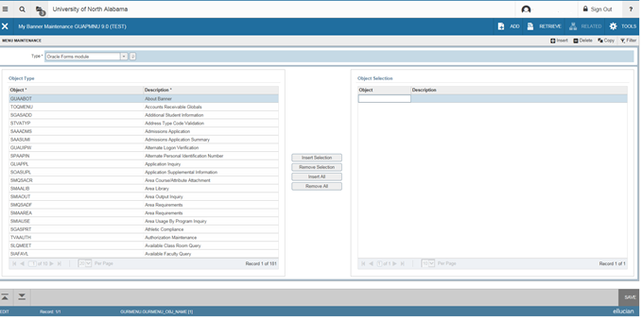

To add objects to your personal menu, select the name from the left pane by double clicking it and then use the Insert buttons in the middle of screen to add to the right pane.

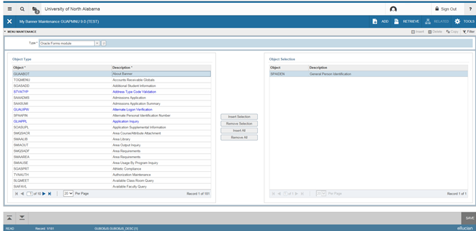

After each page selection to the right pane, select Save in the bottom right hand corner to retain selections.

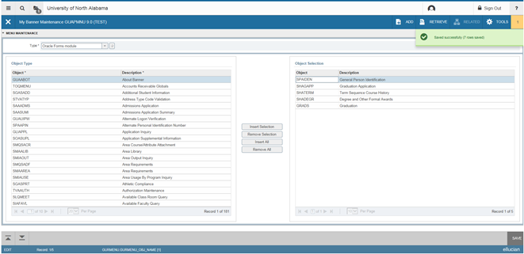

You will have to sign out and sign back in to see changes on your My Banner.

Banner 9 Browser Recommendations:

Banner 9 is a web-based environment and has specific requirements to run smoothly. Here are the recommendations from Ellucian.
- Use Google Chrome
- Use Private Browsing
- Run Separate Sessions In Windows, Not Tabs
- Close Your Browser

Use Google Chrome
Banner 9 is compatible with most browsers (Internet Explorer, Edge, Firefox, etc). Testing by Ellucian has confirmed that Banner 9 runs faster and more efficient in Chrome.

Use Private Browsing
To mitigate Banner 9 issues that can be caused by browser caching, it is recommended to run Banner 9 in private browsing. Called ‘Incognito Window’ in Chrome.

Windows users: create a shortcut to automatically load the Banner 9 website in a new Incognito window. Here's how:
- Open Google Chrome
- Go to the Banner 9 website: https://banner.schoolname.edu
- Open the Chrome menu (it’s a little button at the top right of the screen, directly next to the address bar, and has three vertical dots)
- In the Chrome menu, click More Tools and then click Add to desktop…
- Uncheck the checkbox next to “Open as window”
- Click Add
- Go to your desktop
- Find the new shortcut named "Banner 9 _ School Name” and right-click it
- Click Properties
- Click inside the “Target” text box and at the end of what is already there, type a space and then “--incognito --new-window” (Example: the full text of the text box will look something like this when you’re done: "C:\Program Files (x86)\Google\Chrome\Application\chrome.exe" --profile-directory=Default --app-id=school_identification --incognito --new-window)
- Click OK

To add this shortcut to a taskbar or a Start Menu, right-click again and then click either “Pin to Taskbar” or “Pin to Start Menu”.

Run Separate Sessions In Windows, Not Tabs
Users that have more than one active Banner 9 session, it is recommended to run in separate Chrome windows. Running multiple tab sessions within the same window may cause odd “data and formatting’ behavior if one session times out while another is in use. NOTE: Using the Incognito shortcut will automatically open each Banner session in a new window for you.

Close Your Browser
It’s important to know that each time the user is finished with a Banner 9 session to close the browser window, this included a session in an Incognito window. At minimum, the Banner browser window(s) should be closed at the end of each workday.
Banner 9 Accessibility
Additional options for increased accessibility of Banner 9:

Accessibility Mode for Screen Readers
Accessibility Mode is a setting that can be turned on to change the pattern of navigation within Banner 9 pages and make more buttons accessible to screen readers. To turn on Accessibility Mode for all Banner sessions:
- Open the General User Preferences Maintenance page (GUAUPRF)
- Click the checkbox next to Enable Button Accessibility Mode
- Click Save
- To turn on Accessibility Mode for the current session only, press the keyboard shortcut CTRL+B (Windows) or Command+B (macOS).

Improving Visibility
Banner 9 color scheme is softer and may be problematic to some users. This can be adjusted through Google Accessibility High Contrast extension from the Chrome Web Store.
Note: When this extension is installed, at first, all pages are "inverted", so black becomes white and white becomes black. Press the High Contrast icon in the toolbar to toggle it on and off, or customize the settings on a per-website basis.

- Step 1: Install the extension
- Open Google Accessibility High Contrast extension
- Click the "Add to Chrome" button
- Click the "Add extension" button to confirm
- The extension will install and be immediately set to Invert Colors. Follow the prompt to click the High Contrast icon (to the right of the address bar) and review the options available.

- Step 2: Make the extension available in Incognito mode
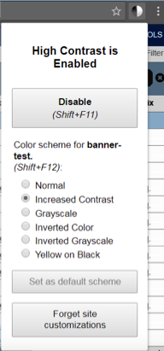
- Visit the settings for the extension (if the link does not work, you can alternatively click the three vertical dots icon at the top right > "More Tools" > "Extensions" > "Details" under High Contrast
- Click the switch next to "Allow in Incognito"

- Step 3: Adjust to your preferences
- You can change the contrast style for each website, or toggle the extension off, by clicking the High Contrast icon to the right of the address bar. There is also a keyboard shortcut to toggle the extension on and off quickly.
- If you prefer any specific setting, you can make it the default each time the extension is turned on by clicking the "Set as default scheme" button.

Banner Keyboard Shortcuts

Action | Banner 9 Keystroke | Banner 8 Keystroke
Cancel Page, Close Current Page, or Cancel Search/Query | Ctrl + Q | Ctrl + Q
Change MEP Context | Alt + Shift + C
Choose/Submit | Enter | Enter
Clear All in Section | Shift + F5 | Shift + F5
Clear One Record | Shift + F4 | Shift + F4
Clear Page or Start Over | F5 | Shift + F7
Count Query | Shift + F2 | Shift + F2
Delete Record | Shift + F6 | Shift + F6
Down/ Next Record | Down Arrow | Down Arrow
Duplicate Item | F3 | F3
Duplicate Selected Record | F4 | F4
Edit | Ctrl + E | Ctrl + E
Execute Filter Query | F8 | F8
Exit | Ctrl + Q | Ctrl + Q
Expand/ Collapse Drop Down Field | Alt + Down Arrow | Click Field
Export | Shift + F1 | Extract Data with Key or Extract Data no Key
First Page | Ctrl + Home
Insert/ Create Record | F6 | F6
Last Page | Ctrl + End
List of Values | F9 | F9
More Information | Ctrl + Shift + U | Alt + H
Next Field or Item | Tab | Tab
Next Page Down | Page Down | Page Down
Next Section | Alt + Page Down | Ctrl + Page Down
Open Menu Directly | Ctrl + M | F5
Open Related Menu | Alt + Shift + R
Open Tools Menu | Alt + Shift + T
Page Tab 1 Page Tab 2, etc. | Ctrl + Shift + 1 Ctrl + Shift + 2
Previous Field or Item | Shift + Tab | Shift + Tab
Previous Page Up | Page Up | Page Up
Previous Section | Alt + Page Up | Ctrl + Page Up
Print | Ctrl + P | Shift + F8
Refresh or Rollback | F5 | Shift + F7
Save | F10 | F10
Search or Open Filter Query | F7 | F7
Select on a Called Page | Alt + S | Shift + F3
Toggle Multi/ Single Records View | Ctrl + G
Up/Previous Record | Up Arrow | Up Arrow

Workflow |  | Banner 9 Keystroke | Banner 8 Keystroke
Release Workflow |  | Alt + Q | Icon or Menu
Submit Workflow |  | Alt + W | Icon or Menu
Banner Document Management |  | Banner 9 Keystroke | Banner 8 Keystroke
Add BDM Documents |  | Alt + A | Icon or Menu
Retrieve BDM Documents |  | Alt + R | Icon or Menu
Application Navigator | Banner 9 Keystroke |  | Banner 8 Keystroke
App Nav - Access Help |  | Ctrl + M
App Nav - Access Menu |  | Ctrl + Y
App Nav - Display Recently Opened Items |  | Ctrl + Shift + L
App Nav - Search |  | Ctrl + Shift + Y
App Nav | Ctrl + Shift + F

Banner 9 Frequently Asked Questions

- What password does Banner 9 use?
- Can I personalize Banner 9's colors?
- Can I make the text larger or smaller?
- Can I make the fields farther apart?
- Where is the My Banner menu?
- How do I update the My Banner menu?

Q: What password does Banner 9 use?
A: Banner 9 uses your password to log in. This is the same password you use for your email and many other UO technology services. More detailed information about Banner passwords is available in this related article.

Q: Can I personalize Banner 9's colors, like I did in Banner 8?
A: No. Ellucian has chosen to not continue this feature in Banner 9.

Q: Can I make the text larger or smaller?
A: Yes. Banner 9 text size responds to settings you can change on your computer or device.
The text size in web browsers is commonly referred to as Zoom. To adjust this in many browsers, you can use the following keyboard shortcuts. (Please note that in some browsers, this may adjust the Zoom for all websites.)
- Windows: Hold CTRL and press + or -
- macOS: Hold Command and press + or -
Banner 9 may also respond to text size settings configured in your operating system.
For further assistance adjusting the text size in your browser or operating system, contact the IT person or group who provides your local desktop support or the Technology Service Desk.

Q: Can I make the fields farther apart?
A: Yes. Banner 9 loads all pages by default in Compact Page Layout. Expanded Page Layout offers more padding between the page fields.
You can switch to Expanded by doing the following:
- Click Tools
- Scroll down to Page Layout
- Click Expanded
Doing so will switch pages for the current Banner session to Expanded Page Layout. This layout must be set again with each new session. There is currently no way to set pages to Expanded by default.

Q: Where is the My Banner menu?
A: In Banner 9, you must open the menu to find your My Banner selections.
Here's how:
- Click the waffle icon on the left to open All Apps And Forms
- Click the seamless.my Banner menu entry
- Load any form from My Banner by clicking it within the list that displays

Q: How do I update the selections in the My Banner menu?
A: The My Banner menu can be updated from GUAPMNU (My Banner Maintenance Form). The Banner 9 version of GUAPMNU functions similarly to the Banner 8 version.
The left box, labeled Object Type, displays available objects.
Note the following:
- The object list may be shown across multiple pages
- You can update how many results are displayed per page, or use the blue arrows to move through the pages
- You can sort the displayed results alphabetically by clicking on the Object or Description column headers
To add available objects to My Banner:
- Double-click them in the Object Type box (they'll turn blue when selected)
- Click "Insert Selection"
- Save (F10)
- The right box, labeled Object Selection, displays objects you have chosen to display in your My Banner.
- To remove objects from My Banner:
- Double-click them in the Object Selection box (they'll turn blue when selected)
- Click "Remove Selection"
- Save (F10)

